Premier and IVR Self-Service Debugging Guide
Version 3.0

Contents
Executive Summary 3
1. Information Needed for Troubleshooting 3
2. Self Service Learning Refresher 5
3. Self-Guided Troubleshooting for Premier /Contact Center/VCC: 6
4. Self-Guided Troubleshooting for CTI: 8
6. Self-Guided Troubleshooting for Soft Phone/BluIP: 9
7. Self-Guided Troubleshooting for Data Delivery Issues: 12
8. Self-Guided Troubleshooting for Outbound Campaign Manager: 19
9. Self-Guided Troubleshooting for Chat: 20
10. Self-Guided Troubleshooting for Telephony: 21
11. Self-Guided Troubleshooting for Email: 22
12. Self-Guided Troubleshooting for Uploading Audio Files, Changing Business Hours and Data files in Premier IVR Application: 23

Overview
The Intent of this guide is to provide a reference guide for Internal Genesys Premier Support teams and Premier Customers for some easy self-guided Troubleshooting techniques.
Audience:
- Premier Contact Center Agents, Supervisors and Admins.
- Self-service IVR- Administrators, Account holders.
- Internal Genesys Customer Success Teams: PS/Support/CSM.
Product Suite Covered
- Premier Contact Center
- Premier CTI
- Premier BluIP Soft Phones
- Data Delivery from CXB Premier Platform: Data files, Audio Files
- CXB IVR
- Premier Outbound Campaign Manager
- Chat and Email

Information Needed for Troubleshooting

In order for the teams to provide better insight into the exact issue, the following information is critical to successfully troubleshoot the issue

For IVR and Contact Center
- Caller ID: Sometimes referred to as the ANI or the number from which the caller is placing the call.
- Dialed Number: The number the caller dialed
- Date and Time of Call: The closer to the actual time the call was active the quicker the troubleshooting will take
- Description of Issue:
- What is expected behavior:
- At what point in the IVR/Contact center workflow is it happening?
- Is it repeatable? If so, note the steps needed to replicate issue:
- Any account number, specific scenario for which issue occurs
- If specific to contact center:
If faced by certain agents: Please note agent’s name, email, skill and call types for which this happens
Details on scenario:
- Business Impact and Criticality:

Have you tried any of the self-guided Troubleshooting tips? If not, Please go through section 3 to 11 in this document to eliminate the possibility of any setup anomaly. Once confirmed, all troubleshooting details requested above along with Browser and Network logs will be required to create a CASE with GENESYS

- Collect Network and Browser logs for Agent/Supervisor/CTI Related Issues
For information on how to capture Browser and Network logs see “Retrieving VCC Browser and Network Logs” in My Support Knowledge.

- To get to the browser log, go to your browser window. For Mozilla Firefox press F12 key. For Google Chrome press the keyboard shortcut Command + Option + J (Mac) or Control + Shift + J (Windows/Linux). The Console window will open.

Mozilla Firefox:
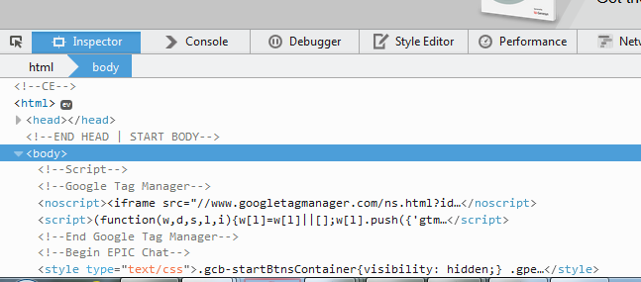

Google Chrome:
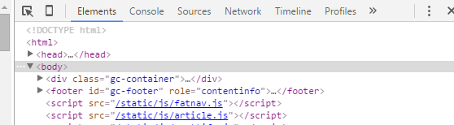
Copy the contents of the window.

- To search for this document;
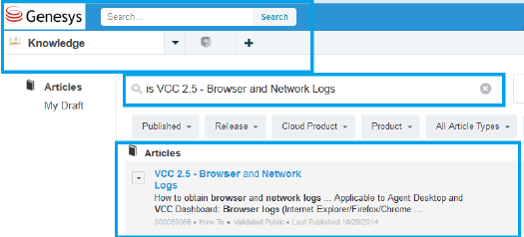

Self Service Learning Refresher
For the most recent link of e-learnings refer to ‘Help’ menu which is accessible from CX Builder account

Premier Contact Center:
- Premier Edition – Administrator Training: http://genesyslab.adobeconnect.com/pe_vcc_administrator/
- Premier Edition – Agent Training: http://genesyslab.adobeconnect.com/pe_vcc_agent/
- Premier Edition – Supervisor Training: http://genesyslab.adobeconnect.com/pe_vcc_supervisor/
- Premier Edition – User Management (Administrator) Training:
http://genesyslab.adobeconnect.com/vcc_administrator_usermanagement/
- VCC Administrator (New Dashboard): http://genesyslab.adobeconnect.com/pe_vcc_263_administrator_newdashboard/
- VCC Supervisor (New Dashboard): http://genesyslab.adobeconnect.com/pe_vcc_263_supervisor_newdashboard/
(Once 2.6.6 is deployed, only this new dashboard will be accessible)

SFDC CTI
- CX Analytics – Basics: http://genesyslab.adobeconnect.com/ss_cxanalytics_basics/
- SFDC CTI Adapter: http://genesyslab.adobeconnect.com/sfdc_cti_adapter/
- SFDC Gplus Adapter: https://elearn.viewcentral.com/content/genesys/PRODUCTION/SFC/menu/Salesforce_Adapter/story.html
- SFDC CTI Adapter Administration: http://genesyslab.adobeconnect.com/sfdc_cti_adapter_administration/
- SFDC Gplus Adapter Administration: http://genesyslab.adobeconnect.com/gplus_adapter_salesforce_administration/

CX Builder:
CX Builder Basics – Create a Call Transfer Page: http://genesyslab.adobeconnect.com/cxbuilder_calltransferpage/
- CX Builder Basics – Create a Message Page: http://genesyslab.adobeconnect.com/cxbuilder_messagepage/
- CX Builder Basics – Create a Question Page: http://genesyslab.adobeconnect.com/cxbuilder_questionpage/
- CX Builder Basics – Create a Schedule Page: http://genesyslab.adobeconnect.com/cxbuilder_schedulepage/
- CX Builder Basics – Create an SMS Page: http://genesyslab.adobeconnect.com/cxbuilder_smspage/
- CX Builder Basics – Create a Voicemail Page: http://genesyslab.adobeconnect.com/cxbuilder_voicemailpage/
- CX Builder – Advanced: Create an ACD Page: http://genesyslab.adobeconnect.com/cxbuilder_create_an_acd_page/
- CX Builder – Basics: http://genesyslab.adobeconnect.com/ss_cxbuilder_basics/
  - CX Builder Advanced – Create a Data Page: http://genesyslab.adobeconnect.com/cxbuilder_datapage/
  - CX Builder Advanced – Create a Logic Page: http://genesyslab.adobeconnect.com/cxbuilder_logicpage/
  - CX Builder Advanced – Create a Transaction Page: http://genesyslab.adobeconnect.com/cxbuilder_transactionpage/

Self-Guided Troubleshooting for Premier /Contact Center/VCC:

Go through the below asked question to rule out any setup anomalies. This guide is for VCC/Premier contact center only (Non- CTI and BluIP phone related interface)

- Symptom: Agent Unable to login in Agent Desktop

- Has supervisor/Admin set that agent up with right email/phone number/skills in contact center?
Please refer to the training guide or recorded training session provided to you by Genesys Professional Services to see how your Agents should be set up. The link to the self-paced e-learning can be found here:
https://genesyslab.adobeconnect.com/_a1160209796/vcc_administrator_usermanagement/
Also refer to the e-learning: VCC Administrator (New Dashboard): http://genesyslab.adobeconnect.com/pe_vcc_263_administrator_newdashboard/

- If not, Agent has to be set up first with the right skill, phone number and other details by the supervisor by logging Into the ARC/VCC supervisor dashboard.
- Agent should be sent login instructions by supervisors and agent needs to be logged into the Agent desktop and in Ready state to receive calls. Refer to Login instructions below.
- Has agent ever tried logging in before?
- If not, check step 1 and send login instructions to agents.
- The Password reset link is valid for 24 hours only, if not setup within that period, ask supervisors to resend reset link

If agent had logged in before, and login is not working now:
- Ask agent to Clear cookies and Cache on browsers
- Make sure supported web browser is used: Chrome, Firefox, IE-10 and IE-11 are supported
- Make sure correct login links are used:

If using VCC 1, the login link is:
https://sb.angel.com/login/login-page.jsp

If using Premier 2.6 platform, the agent login link is: https://premier.angel.com/ui/ad/v1/index.html

- Symptom: Agent not getting calls/IVR calls not getting routed properly.
Confirm that
- Agent is logged into the Premier Contact Center
- The correct skill, proficiency, and phone number is assigned to agent
- Agent is in Ready state. Agent has set their state to Ready in the Agent Desktop
- Confirm that calls are being routed to contact center with the skill of agent in question. Confirm another agent with the same skill is able to receive calls.
- Is the other agent with the same skill able to receive calls using the same telephony device (cell phone, landline or IP phone)
If using IP phones: Make sure agent is logged into endpoint. Also Refer to BluIP troubleshooting guide in section 6

- Symptom: Premier Edition Agent UI status doesn't match in VCC dashboard

• Collect browser and network logs
- Have the agent
      - Log out
      - Clear their cache from the beginning of time
      - Close the browser
      - Re-open a new browser
      - Log back into Genesys
      - Change the agent status

• The Supervisor should monitor the agent's status using the VCC Dashboard. If the agent's status still doesn't match open a case and provide
• Browser logs
• Network logs

- Symptom: When an agent is on an active call the call is going to the Agent’s voicemail instead of going to next available agent
- Check the number of rings/time after which call goes to the phone systems voicemail.
- “Missed Call” time-out needs to be shorter than the time configured for the phone system to connect the call to voicemail. There is a setting in the ACD page which defines the number of seconds after which call gets routed to next available agent. If this timer is greater the in ACD page (default 25 seconds) than the number of seconds the call can ring before voicemail (say 15 seconds) is connected then this issue will occur.
- The setting in ACD page should be changed only if it’s affecting majority of phones, else the phone system settings should not be adjusted.

- When an Agent places an Outbound from VCC the call not going through:
- Confirm the number dialed is correctly formatted.
  - For US numbers, +1 xxx-xxx-xxxx,
  - If calling from the US and dialing an international number, prefix with:+011 country code
- How is the agent placing the outbound call (IP phone (endpoint) or Agent Desktop)?
Note that outbound calls cannot be made using BluIP/IP endpoint phone, only Agent Desktop or CTI supports dialing outbound calls.
- Calls are being received at the VCC Dashboard but not the Agent Desktop when both are open:
- Calls can be received within the VCC Dashboard if the supervisor or Admin also have the agent role assigned.

Self-Guided Troubleshooting for CTI Adapter:

- Symptom: SFDC Admin cannot add users to CTI Adapter list (call center)
Make sure instructions for adding agents in Call Center are added, per attachment.
- Are there any other CTI adapters this SFDC instance? If yes, SFDC users can be assigned to one Call Center at a time. Remove the agent from the other Call Center assigned
(Sample Installation Guide attached)

- Symptom: Agent does not see CTI in Zendesk
- Ensure the Adapter is correctly configured
- Ensure CTI permissions within Zendesk are correct.
This is typically a configuration or permissions issue

- Symptom: CTI adapter is showing a white screen
- Ensure the customer using one of the supported browsers. The most common reason for this issue is that an unsupported browser is being used. Supported browsers, are IE10 and IE11, Firefox, and Chrome.
- Does the customer have a good network connection? If not, that can be a possible issue

4. Symptom: VCC Dashboard is shown in Zendesk environment
- The Zendesk CTI adapter must have the “VCC Dashboard URL*” updated from https://vcc3.angel.com/ui/sd/v1/index.html to https://premier.angel.com/ui/dashboard/#/login.

- Symptom: Call Activity in Zendesk is not being posted to the ticket originally popped by the call.
- It is best practice to disable call activity within CTI adapter setting “Disable Call Activity”. Otherwise call activity is posted to the ticket the agent is viewing at the time the call ends.

Self-Guided Troubleshooting for IP Endpoint (BluIP softphones):

Make sure below mentioned VOIP practices are followed:

- IP Endpoint: The “Genesys VoIP” application.

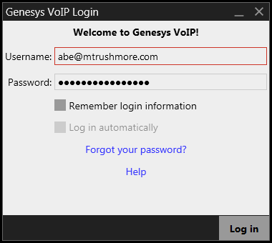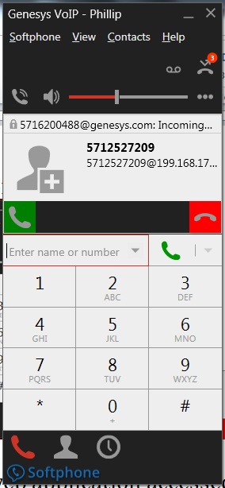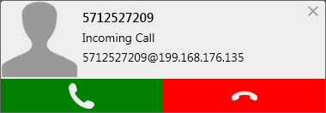

- Genesys Agent Desktop:

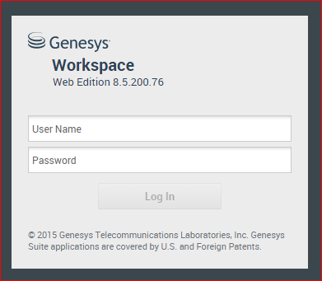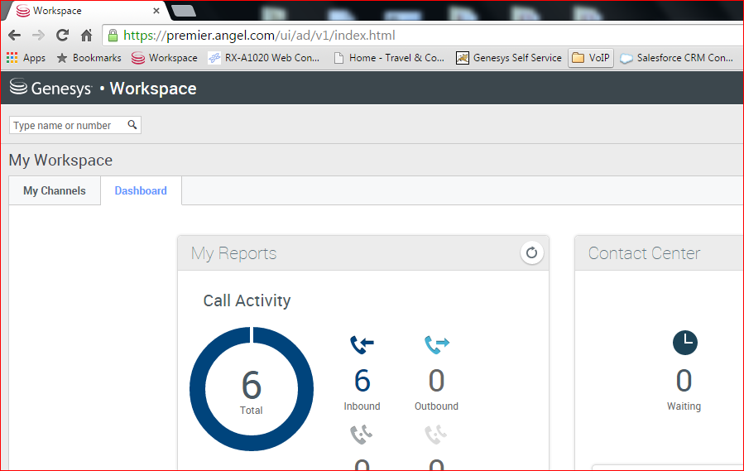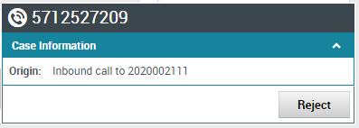

Best Practices:
- DO Log In to the IP Endpoint before logging into the Genesys Agent Desktop. These require separate logins, and the Endpoint should be READY first.
- DO make sure your Endpoint is logged into using YOUR username. To be sure, if the endpoint is already open when you start work to log out of the endpoint and log back in.
- DO only use the endpoint to answer calls using the green button. All other call controls (hold, reject, hang-up) must be done through the Agent Desktop.
- DON’T click the red button in the endpoint to reject a call. Only reject a call from the Agent Desktop
- DO Log Out of the endpoint before letting someone use the PC (e.g. at the end of a shift).
- DON’T check the “Log in automatically” button on the endpoint login screen
- OPTION: Uncheck “Remember login information” in the endpoint login screen. This will insure user credentials will be required at every login.

Enabling Auto Answer functionality
- Enabling Auto-Answer on the Genesys VoIP endpoint will cause the endpoint to connect to the call automatically after a specified period of time. By default, when Auto Answer is enabled, the endpoint will immediately connect the call with a delay of zero seconds.
- In the default configuration, Auto Answer is NOT turned on, and must be enabled on a per-endpoint basis. The controls to enable Auto Answer are in the main screen after logging in. Click the “…” icon to expose the Auto Answer option, then click Auto Answer so the check mark appears.
- 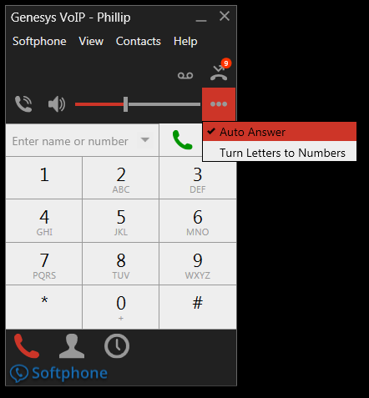

Setting Auto Answer Delay
- The default Auto-Answer Delay is zero seconds, but can be changed to add a delay up to 5 seconds. If Auto Answer is desired, Genesys recommends using the default of zero seconds, as this prevents the call reject (red) button from being clicked in the endpoint. If call rejection is allowed, it must only be done from the Agent Desktop
- You can change the Auto Answer delay starting from the main menu under: Softphone -> Preferences, then select the “Calls” tab in the pop-up menu, then choose the delay.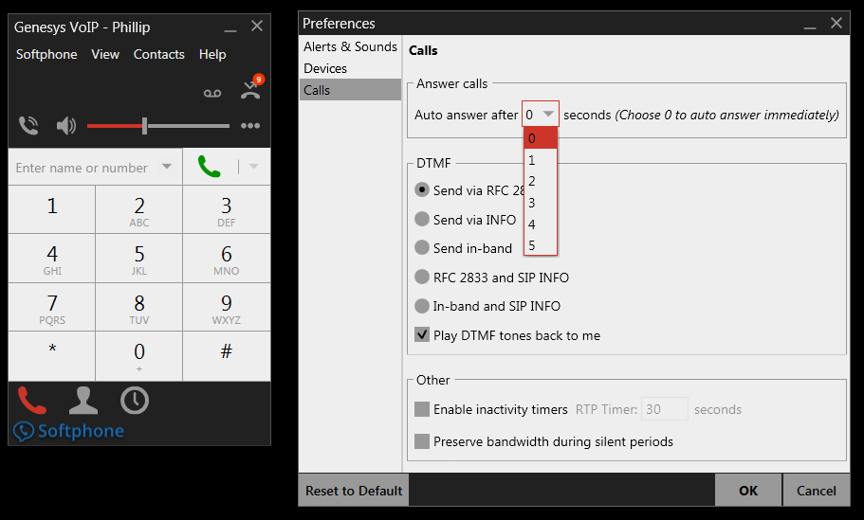
- Inserting DTMF Tones into an Active Call
- Although the VoIP Endpoint cannot be used directly to place outbound calls from the dialpad (an agent can use the Agent Desktop to place calls), the VoIP endpoint can be used to insert DTMF tones during a call. To do so, the agent must first click in the “active call window” within the endpoint before clicking digits on the dialpad. By default, the cursor does not start in the “active call window”.
  - Symptom: Agents unable to login into Endpoint
- Make sure agents have phone assigned and setup created in BluIP portal. Only Genesys employees/CARE have access to BluIP Portal.
- If the agent has a login and a phone is setup resent password the agent password
- If resend password doesn’t work, deactivate and reactivate the agent in portal. If that doesn’t work, assign a new number to the agent in BluIP portal
  - Symptom: Audio quality issues
- The Contact Center User network must be certified through the pre-qualification process. This process is provided below

Collection BLUIP LOGS
Refer to Soft Phone debugging Guide to collect logs for softphone related issues. This is needed for the support case.

Self-Guided Troubleshooting for Data Delivery Issues:

- Symptom : Data File (.csv/.xlx) set for auto delivery- Not getting delivered:

- Was the data file successfully delivered previously
  - If has never worked, then confirm configured is correctly
  - Confirm exact name of the data file in question and for that,
    - Confirm email address for delivery/ftp/sftp details are correct.
    - Confirm FTP configuration (for example data can be delivered but data is then deleted)
- Check the number of rows that exist in the data file. If source data file is at 50k it means the data file is full
- Check - if old data rows is getting deleted . If not, you will exceed the 50 k data file limit
- Check frequency of delivery, ensure that data file is set for delivery per schedule
- Set a “send now” from data file to check if this is issue with subscription. If “send now “works, it means the subscription configuration may be incorrect

- Symptom: Call recordings for Inbound/Outbound not getting delivered in FTP
- Confirm FTP details are correct. The details must include: host, port, username, password and directory, if needed.
- Confirm if files have been successfully delivered previously
  - (If was never setup- then check setup in SiteBuilder, else check if FTP has an issue).

  - To set up FTP delivery, log in to CX Builder. Go to HOME tab and choose “All Data Files”.
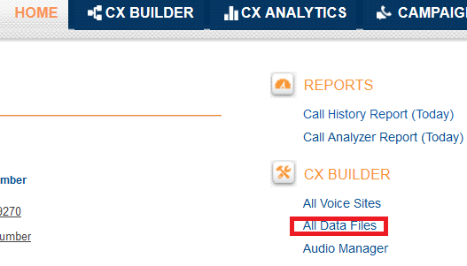

- Choose the correct file and click “Edit”.
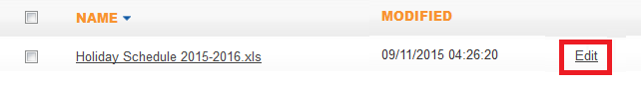

- Click the “+” button.
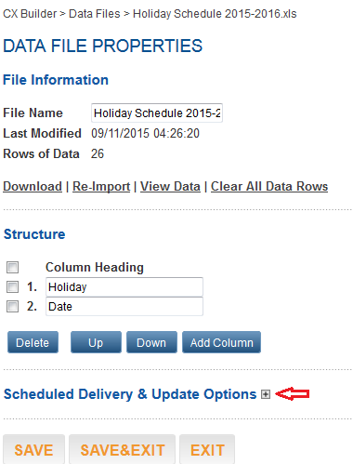

- Click the option “Enable Delivery” and fill in the required data. Set the time of delivery.
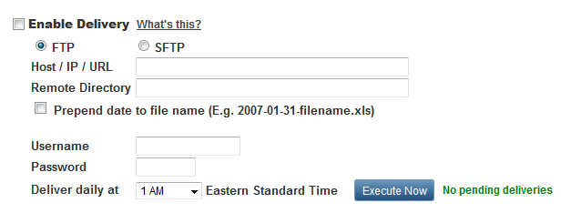
- If inbound is getting delivered but outbound call recording is not getting delivered - Then open a Genesys support ticket/case

- Symptom: Only headers for data files are being delivered
- Confirm that calls were made and valid data is present for the timeframe.
  - To check if there is any valid data regarding calls, go to your CX Builder account and open CX Analytics tab.
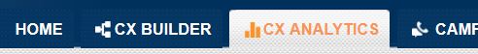
  - Go to STANDARD REPORTS and section CALL HISTORY REPORT, choose requested time frame and phone number, click GO.
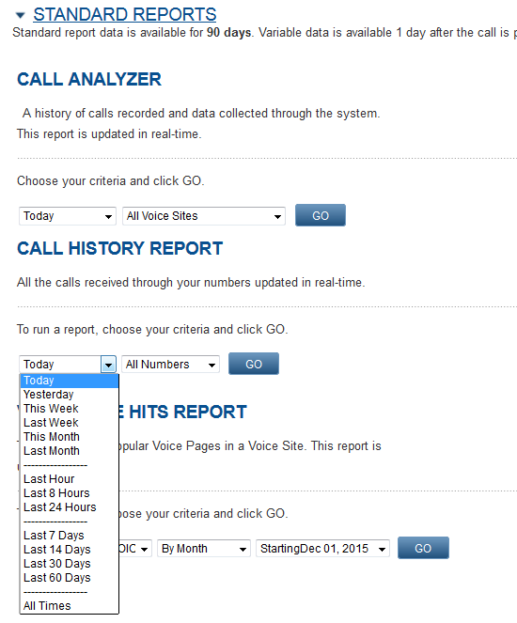
- Check data file delivery settings to see if only new rows are sent.
  - To check data file delivery settings, log in to CX Builder. Go to HOME tab and choose “All Data Files”.

  - Choose the correct file and click “Edit”.
  - Click the “+” button.
  - Check if option “Deliver only new rows of data” is enabled.
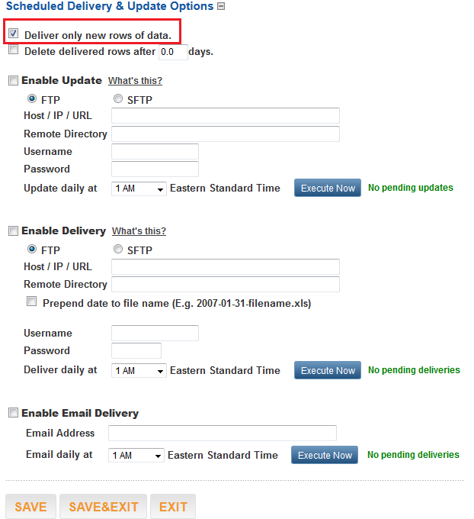

- Note that when no calls are made, the system will deliver only the data file headers regardless if it's using all data rows or only new rows of data for delivery
Such a situation would occur when there is no traffic to the voice site or no agents log in on weekends or holidays, if the delivery settings are to send a file each day.
- Follow the steps from item 1
4. Symptom: Data from web service not delivered/posted correctly
- Test the transaction page responsible for delivery and confirm it is correct configured. If Genesys built scripts- Hit the “Run” Test and confirm “Success”.
    - Go to your CX Builder account and open CX Builder tab. Choose the IVR by clicking on its name.
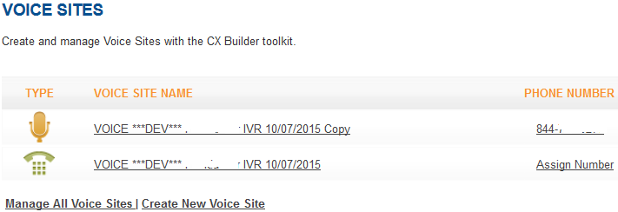
  - Go to the desired transaction page, enter (or check relevant test data) and click “Run Test
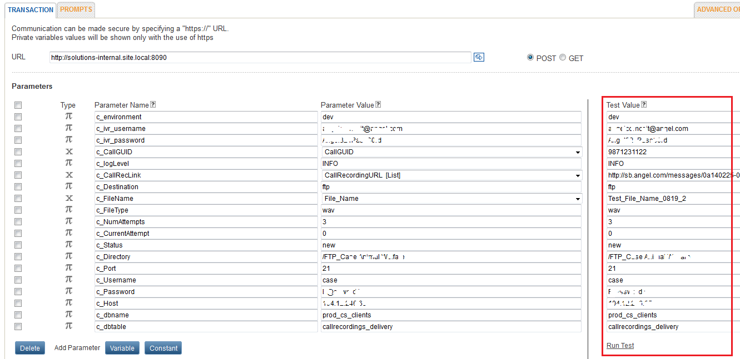
  - Check if “TransactionStatus” equals “Success”.
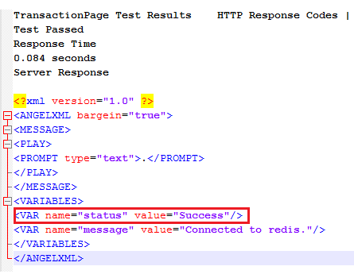
  - Confirm all the fields are set correctly (all data that needs to be delivered and the delivery 'address').

  - Confirm that the transaction page is being 'hit' for the calls in question and the data is populated.
    - Go to your CX Builder account and open CX Analytics tab.
    - Go to STANDARD REPORTS and section CALL HISTORY REPORT, choose requested time frame and phone number, click GO.
    - Click “Variables” next to the details of call in question.
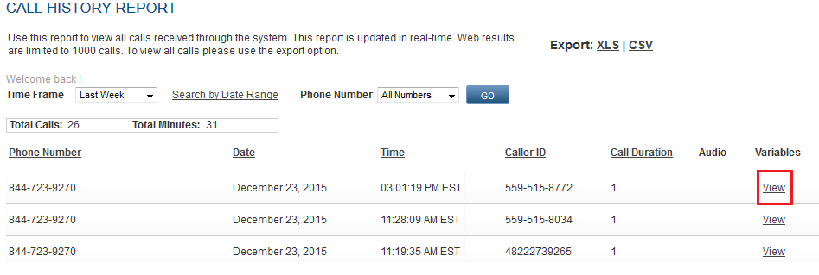
    - Look for the number of transaction page under “Page History” variable.
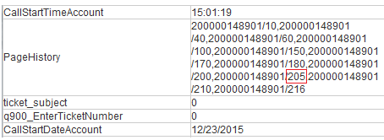

    - Another way is to check the Page Hits report (only available when CX Analytics enabled).
- In CX Analytics tab choose IVR reports and click on Page Hits report in VUI Analysis group, Choose timeframe or enter specific date range:

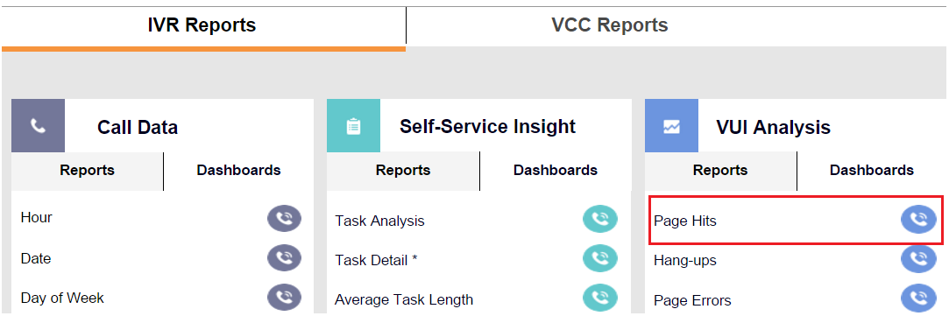

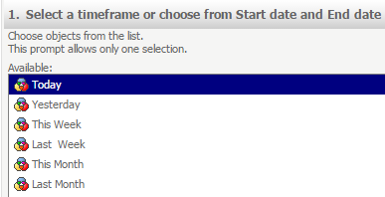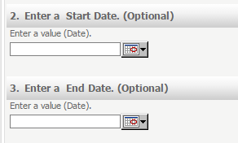
- Select the right voice site from the list and Run the report:
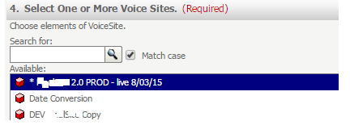
- Find the row with page in question and click on “Hits” value and find the call for analysis:
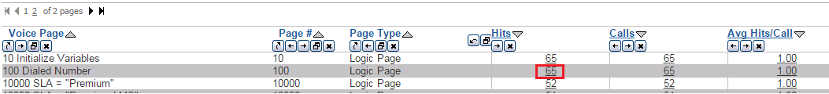
- Check debug emails from transaction page.
    - To check, if debug emails are to be sent, go to the site by clicking on its name in CX Builder. Enter the page that you would like to check.
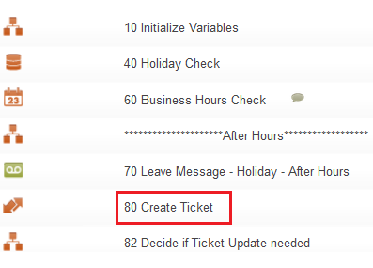
    - Go to ADVANCED OPTIONS tab:
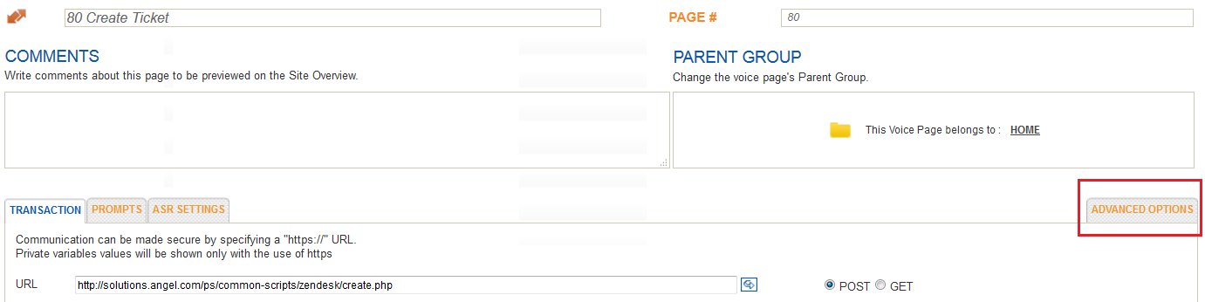
    - Check settings for “Email Debugging”:
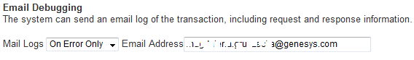
    - Confirm no special characters are sent in data fields as they may create issues.
- If the web service is not working despite everything being set correctly on the IVR side, confirm that the IP used by the IVR is accepted by the destination system. For this open a CASE with Genesys Support
- Confirm that the destination system supports the correct certificates. For this open a CASE with Genesys Support

Self-Guided Troubleshooting for Outbound Campaign Manager:

1. Symptom: Campaign in Campaign Manager is set, but no end users not receiving calls
- Make sure OCM account setup is setup correctly.
  - Follow the instructions for OCM below.
- Make sure right Outbound API key has been linked to account and that Account is enabled for Outbound. (If you were able to run and receive calls for a campaign earlier, this should not be an issue)
To learn if the account is enabled, it is necessary to create a CASE with GENESYS.
- Make sure campaigns are correctly setup - Calling Windows, Site name etc.
- Ensure data file which is set in Campaign Manager conforms to the correct format specified in the Design.
- Make sure Settings in Sitebuilder under Outbound section are correct (Detection thresholds and calling windows. Refer to attached manuals above (zip file)

2. Symptom: Single Sign On doesn't work when logging into OCM from CXB
- Only Main Account holders can use Single Sign On. Logging in through CSR doesn’t allow you to use SSO (Single Sign On).
  - If the user is the main account holder, then SSO may need to be enabled. Open CASE with GENESYS.
  - If the user is the main account holder and SSO is enabled, however the email address for CXB & OCM doesn't match, then Ops will need to disable SSO, have an OCM account created that matches the main account holder address and re-enabled SSO. In this case is creation of a CASE with GENESYS.
  - If they are the main account holder has SSO enabled, and email address for CXB & OCM match, then Ops needs to disabled SSO and re-enabled it. . In this case is creation of a CASE with GENESYS.
- Confirm the OCM user email address matches the main account holder email address?
3. Can we have an OCM account per sub user?
- No, if a customer needs everyone to see Campaigns started or completed all users within the customer will need to share a single OCM account. Same for OCM reporting. Otherwise, Genesys can create separate OCM accounts for users. In this case is creation of a CASE with GENESYS.
4. Can we have a test OCM account so production data doesn’t get mixed with test data?
- We can provide a test OCM account so production data doesn't get mixed with test data. Ops will need to be involved for setting up the OCM account. In this case is creation of a CASE with GENESYS.

Self-Guided Troubleshooting for Chat:

1. Symptom: Widget doesn’t display
Widget requires both HTML code and javascript file to be implemented on the customer website.
- Has the HTML code been implemented?
- Has the javascript file been implemented?

2. Symptom: Widget is blank after starting chat
  - The Client ID needs to be added to the HTML code. It can obtained by opening a ticket with the Genesys Care team, who in turn need Genesys operations involvement
  - Has the Client ID been inserted in to the widget HTML code?

3. Symptom: Chat Icon is visible after hours
- Chat Icon is visible at all times of the day. When customer starts chat to reach an agent they get a message an agent will be with you shortly even if it is after hours. The client needs to include in their web site code to have the icon disappear after hours.

4. Client wants to modify the fields that is captured to initiate a chat.
- Product limitation - we can capture up to 5 variables (First Name, Last Name, Phone Number, Email, and Subject). The captured variables can be decreased, but anything that is set has to be filled out before a chat can be initiated. Customer needs to go into HTML file and remove the fields that aren't required. The only field that cannot be removed is the email address. All other fields can be removed.

5. Symptom: Client cannot start chat without filling out all fields.
- Product Limitation - we need all fields to be filled out before a chat can be initiated. We can decrease the amount of variables needed to initialize a chat; please see #4.

6. Symptom: Site says that Chat feature is not recognized.
- Has all the customer provided all domain names for their web sites (including UAT and Production)? If not, Ops will need to do a deployment to allow the domains access to chat.
- Symptom : Customer wants the transcripts be turned off
This can be done by the customer. They will need to go into the Javascript and set the variable transcripted = false.

Self-Guided Troubleshooting for Telephony:

Support teams will require the following information for troubleshooting

For Telephony Issues
- Caller ID:
- Dialed Number:
- Date and Time of Call:
- Description of Issue:
- What is expected behavior:
- At what point in the IVR/Contact center workflow is it happening?
- Is it repeatable? If so, note the steps needed to replicate issue:
- Any account number, specific scenario for which issue occurs
- If specific to contact center:
If faced by certain agents: Please note agent’s name, email, skill and call types for which this happens
Details on scenario:
- Business Impact and Criticality:

1. Symptom: One way audio, Latency in Audio

Note: For International Locations, Genesys cannot guarantee Quality of Service (QoS) without a MPLS circuit
- Check if softphone, headset issue (Does it happen all the time or under specific scenarios/hardware/software setup)
- Understand and document the exact use case
2. Symptom: Callers hear a clicking sound in IVR
- When the Genesys system does data look up (Using web services), callers can hear a clicking sound if the web service response is greater than 1-2 seconds. This may happen when: Web service response time takes longer due to network connectivity (If hosted on customer side)
- The max timeout is 30 seconds by default- Meaning if we fail to get a response within 30 seconds, callers will be routed based on settings in Sitebuilder (On error destination)

Self-Guided Troubleshooting for Email:

  - Symptom: Email accounts are not configured: Refer attachment
  - Symptom: Emails are being received by agent or popped via Agent Desktop
- Check if skill is enabled for email account in contact center setting, Email in the Dashboard.
- Check if the skill used by the email account is assigned to the agent
  - Symptom: Customer: We are in the process of moving a data center into a new building which will require us to change the IP addresses of our mail servers. I know that your system connects to a mailbox in our environment via POP server and I was wondering if someone could let me know what your configuration is for that connection? Are you connecting via IP address and if so what IP address are you currently using? This would be very helpful in planning out the move.
- The Email settings within the VCC Dashboard will need to be updated
- All emails from the current email domain should not be migrated to the new Email Domain. Since all existing emails in production have already been triggered with an Automatic reply, if we receive the same emails from the new IP this will also trigger automatic reply and the recipient will receive it twice.
- All existing emails (contact history) in current production needs to be marked as completed. After moving to the new domain, these emails will not be included and cannot be accessed from the dashboard once we migrate
- For Best Practice we need to create new email accounts to allow testing the new configuration. The new email server should have an empty mailbox and no new emails stored (Inbox, Spam, Drafts, etc). Once Testing is successful, we will make the switch and they can cut over their email traffic to this new server (for new incoming emails only). The old accounts can be deleted once the new email server is validated
- Here’s a short overview of best practices on incoming emails handling:
- Standard Mailer service
  - When agent is presented with email, he/she accepts the email
  - The agent clicks reply. The original email is placed in the agent bin, updates are applied to the replied email.
  - The agent enters and saves any required notes and disposition for the email*
  - The agent responds to the customer’s question
  - The agent sends the reply email.
  - The agent marks the email done. The email is sent and the agent can receive next interaction

- For Mass Mailer Service
  - When agent is presented with email, he/she accepts the email
  - The agent copies the return email address to the clipboard
  - The agent opens the Contract Directory and searches for contact by email address
  - The agent completes contact if new and/or clicks on the send email icon
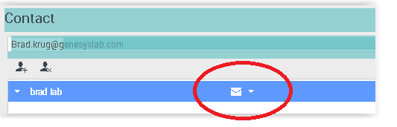
  - This generates a new email which will be used to reply to the customer.
  - The agent copies the original email content, if required, and answers the customer’s question, sets disposition and saves notes. The reply for the email is sent. The Original email will still be on desktop. The agent adds a note that a reply was sent to the customer via a separate email and marks this email as done.

Self-Guided Troubleshooting for Uploading Audio Files, Changing Business Hours and Data files in Premier IVR Application:

Before making any changes to production site, Ensure customer /concerned party has:
- CX Builder Access
- Reviewed CX Builder Basics training, If not please refer to trainings below:
- As a best practice - All changes needed to be made in a copy site first, tested and only once confirmed changes can be replicated in production site

CX Builder E-learnings: For the most recent link of e-learnings refer to ‘Help’ section which is accessible from CX Builder account)
CX Builder – Basics: http://genesyslab.adobeconnect.com/ss_cxbuilder_basics/
CX Builder Basics – Create a Message Page: http://genesyslab.adobeconnect.com/cxbuilder_messagepage/
CX Builder Basics – Create a Question Page: http://genesyslab.adobeconnect.com/cxbuilder_questionpage/
CX Builder Basics – Create a Schedule Page: http://genesyslab.adobeconnect.com/cxbuilder_schedulepage/
CX Builder Basics – Create a Voicemail Page: http://genesyslab.adobeconnect.com/cxbuilder_voicemailpage/
CX Builder Advanced – Create a Data Page: http://genesyslab.adobeconnect.com/cxbuilder_datapage/
CX Builder Advanced – Create a Logic Page: http://genesyslab.adobeconnect.com/cxbuilder_logicpage/
  - CX Builder Advanced – Create a Transaction Page: http://genesyslab.adobeconnect.com/cxbuilder_transactionpage/

- Symptom: Need help changing business hours check, Updating Holiday List, updating audio files with new prompt message.

- Note: Audio files announcing a Message can be updated with only changing audio files. Any prompt change which has a change in menu, drives action in IVR also needs logic change in the application and cannot be achieved with just a prompt change.

- Please refer to following step by step guide to update Data files, schedule pages and Audio files

